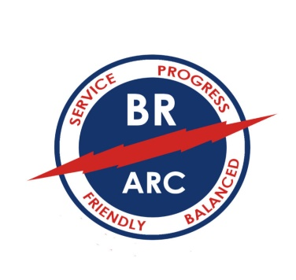
BATON ROUGE AMATEUR RADIO CLUB
PO BOX 4004
BATON ROUGE, LA 70821
brarc@brarc.org brarc.org

New Member Application Date: ___________________
Update Information for Current Member
New Ham, Complimentary 12 Month Membership

Name: ________________________________________________________ Call: __________________
Address: ________________________________________________ License Class: _________________
City: ______________________________________ State: _________________ Zip: ______________
Home Phone: ___________________________ Cell Phone: ___________________________________
Email: _______________________________________________________________________________
Year First Licensed: _______ Birthday: _________ ARES Member: Yes \ No ARRL Member: Yes \ No
Name and call sign of other Hams in your household: List Phone\Email in Club Directory: Yes \ No

Please indicate your areas of interest: Circle all that apply

Licensing Instructor | Newsletter Contributor | Net Control Operator | Elmering | DX
Technical Assistance | Publicity/Public Relations | Emergency Operations | Satellite | CW
Antenna Design | Repeater Operations | Public Service | Scouting | Phone
Project Building | Volunteer Examiner | Special Event Stations | Social Events | Digital
Contesting | Internet Linking | Portable Operations | Solar Activity | HF
ARES/RACES | Finance Committee | Software Development | Field Day | VHF/UHF
Traffic Handling (NTS) | Direction Finding/Tracking | Youth Outreach | RFI/TVI | QRP
Other:

- Regular Member: $25 per year
- Family of Regular Member: Not Applicable
- Student K-12 Member: $10 per year
- Unlicensed Member: $10 per year
- New Licensee, Complimentary 12 month membership

Dues may be submitted in person at a BRARC monthly club meeting or mailed to the above address. Please make checks payable to Baton Rouge Amateur Radio Club. To pay online email form to brarc@brarc.org

