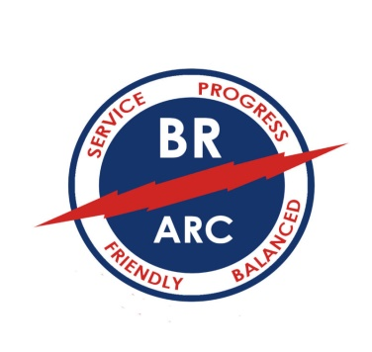
BATON ROUGE AMATEUR RADIO CLUB

PO BOX 4004
BATON ROUGE, LA 70821
brarc@brarc.org brarc.org

☐New Member Application Date: ___ _____ ______
☐ Update Information for Current Member
☐ New Licensee, Complimentary Membership for Remainder of Year

Name: ____ __________ _____________________________ Call: ___ _____ ______
Address: ________________________________________________ License Class: _________________
City: __________________________________ State: _________________ Zip: __________________
Home Phone: ___________________________ Cell Phone: ___________________________________
Email: _______________________________________________________________________________
Year First Licensed: _______ ARES Member: Yes \ No ARRL Member: Yes \ No
Name/call sign of other Hams in your household: List in Club Directory Phone Yes\ No Email Yes\ No

☐ Regular Member: $25 per year
☐ Family of Regular Member: No payment is due
☐ Student K-12 Member: $10 per year

Dues may be submitted in person at a BRARC monthly club meeting or mailed to the above address. Checks are made payable to Baton Rouge Amateur Radio Club. To use PayPal please see www.brarc/membership.

Please submit Membership Application Form with your payment.

